H.K.PEIRIS

IT13116002

4th Year

Lab - 01

AWS WINDOWS

ESBPII

Amazon EC2 Linux Instances

1. 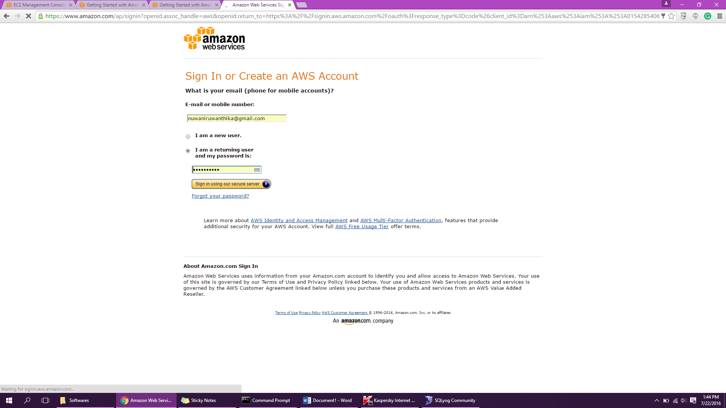Create the account.
2. Creating an instance
   1. 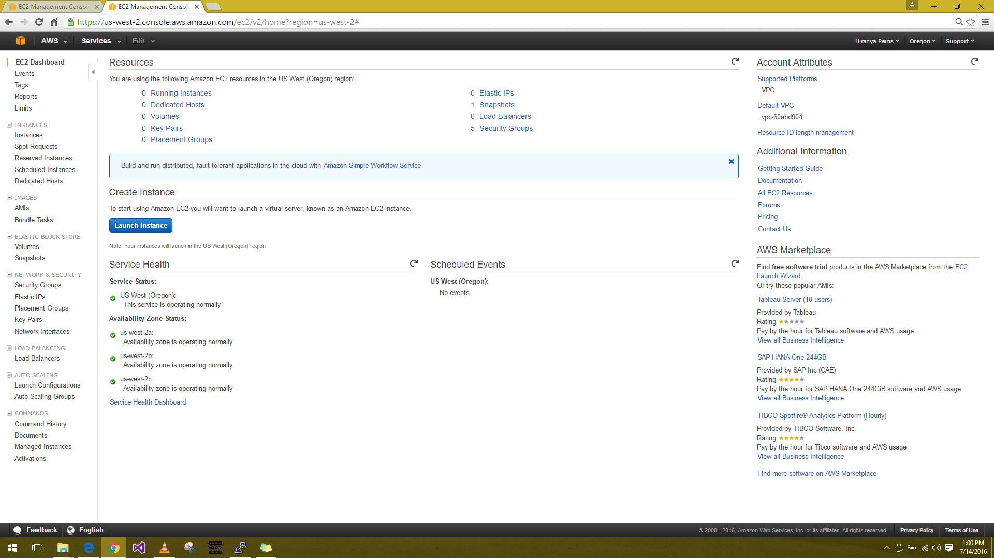EC2 Console dashboard 🡪 Launch Instance
   2. Choose an Amazon Machine Image (AMI)

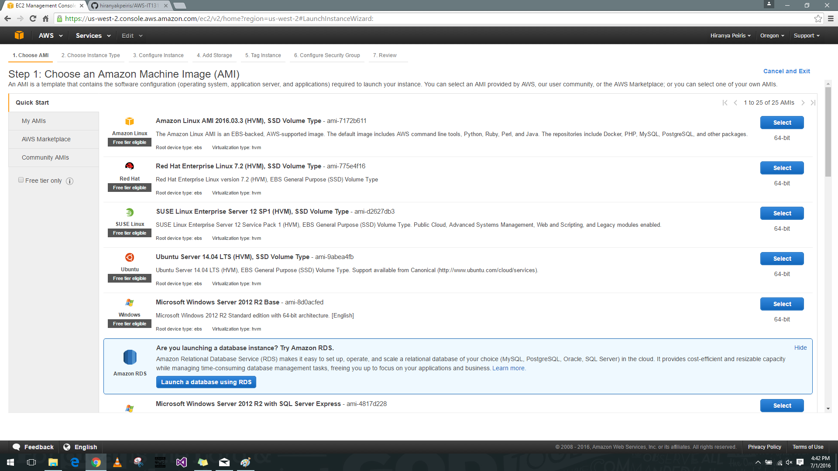

* 1. Choosing an instance type page 🡪 t2.micro - Default (**Free tier eligible**)

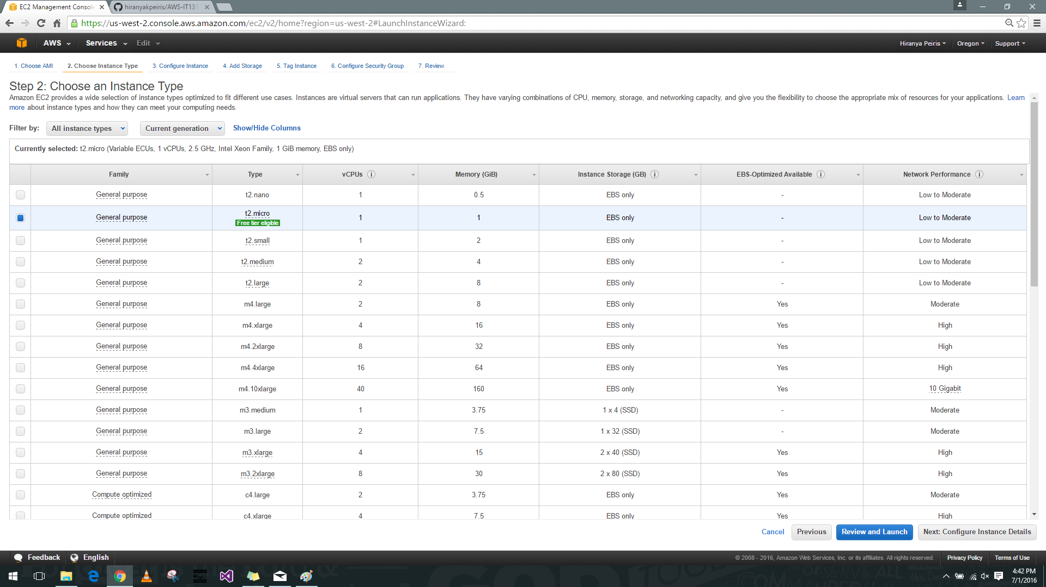

* 1. Review instance launch page

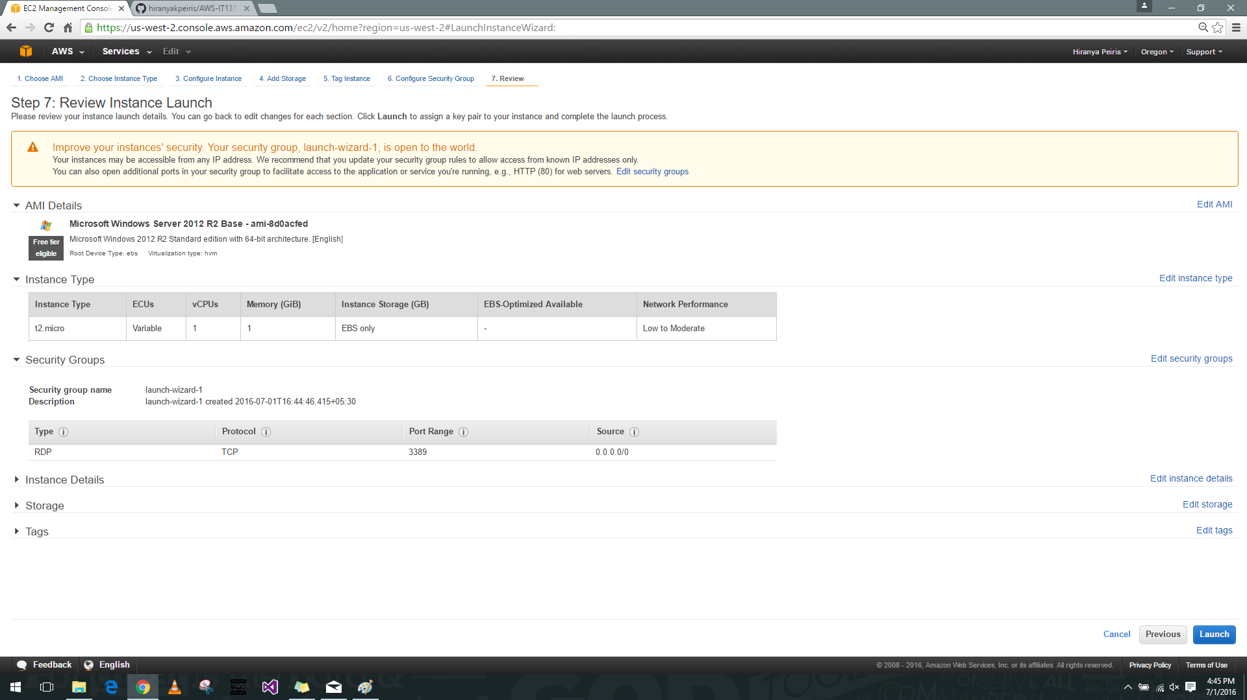

* 1. Select an existing security group.

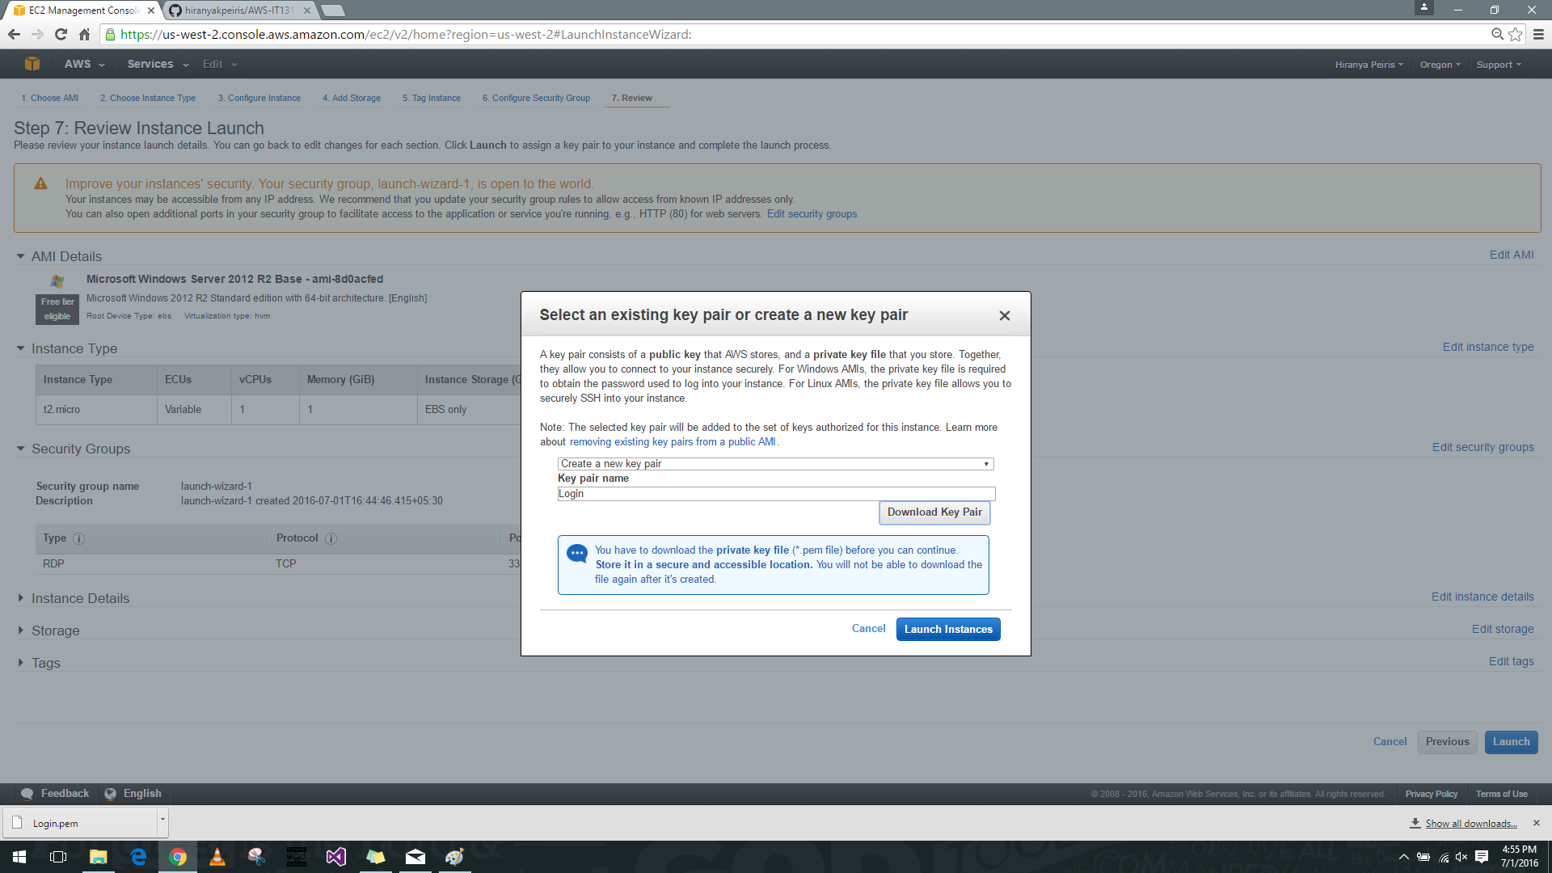

* 1. Choose Launch Instances

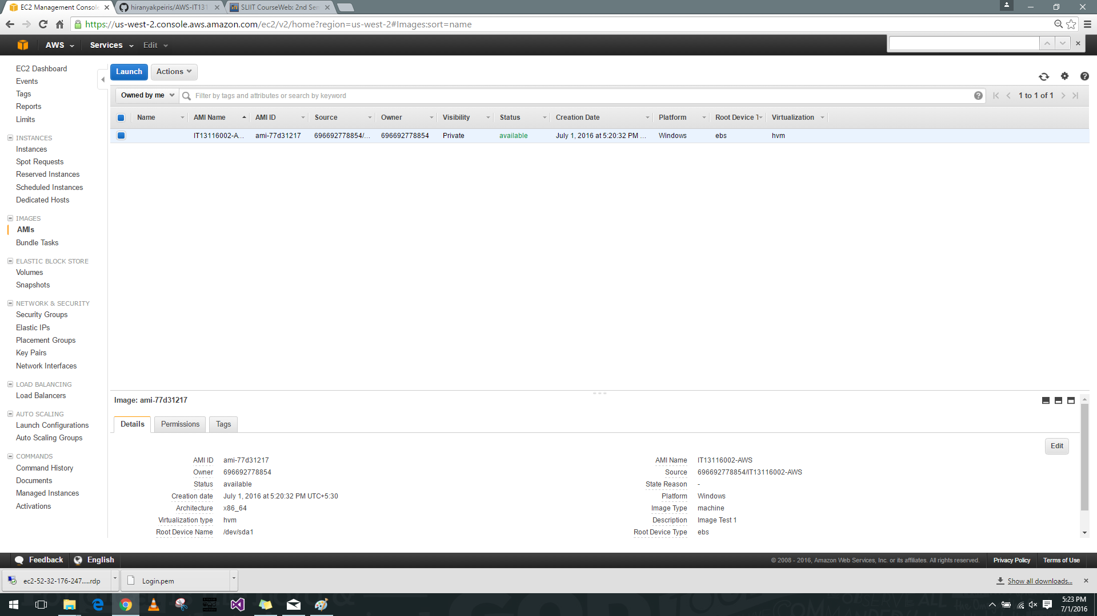

* 1. In the Connect to Your Instance dialog box, choose Get Password and Download Remote Desktop File

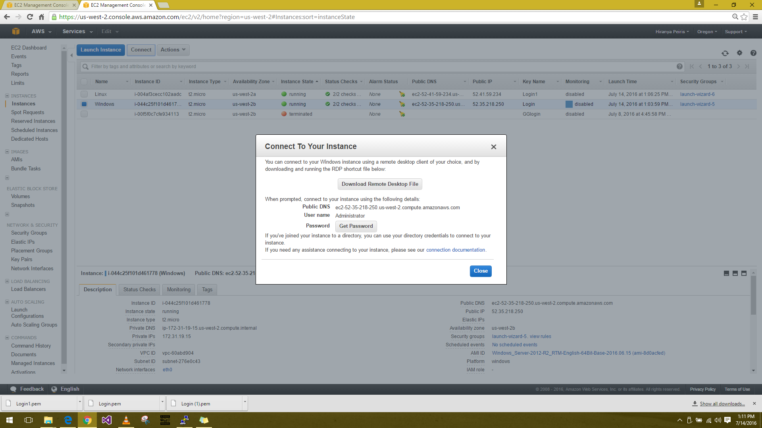

* 1. When prompted, log in to the instance, using the administrator account for the operating system and the password that you recorded or copied previously.

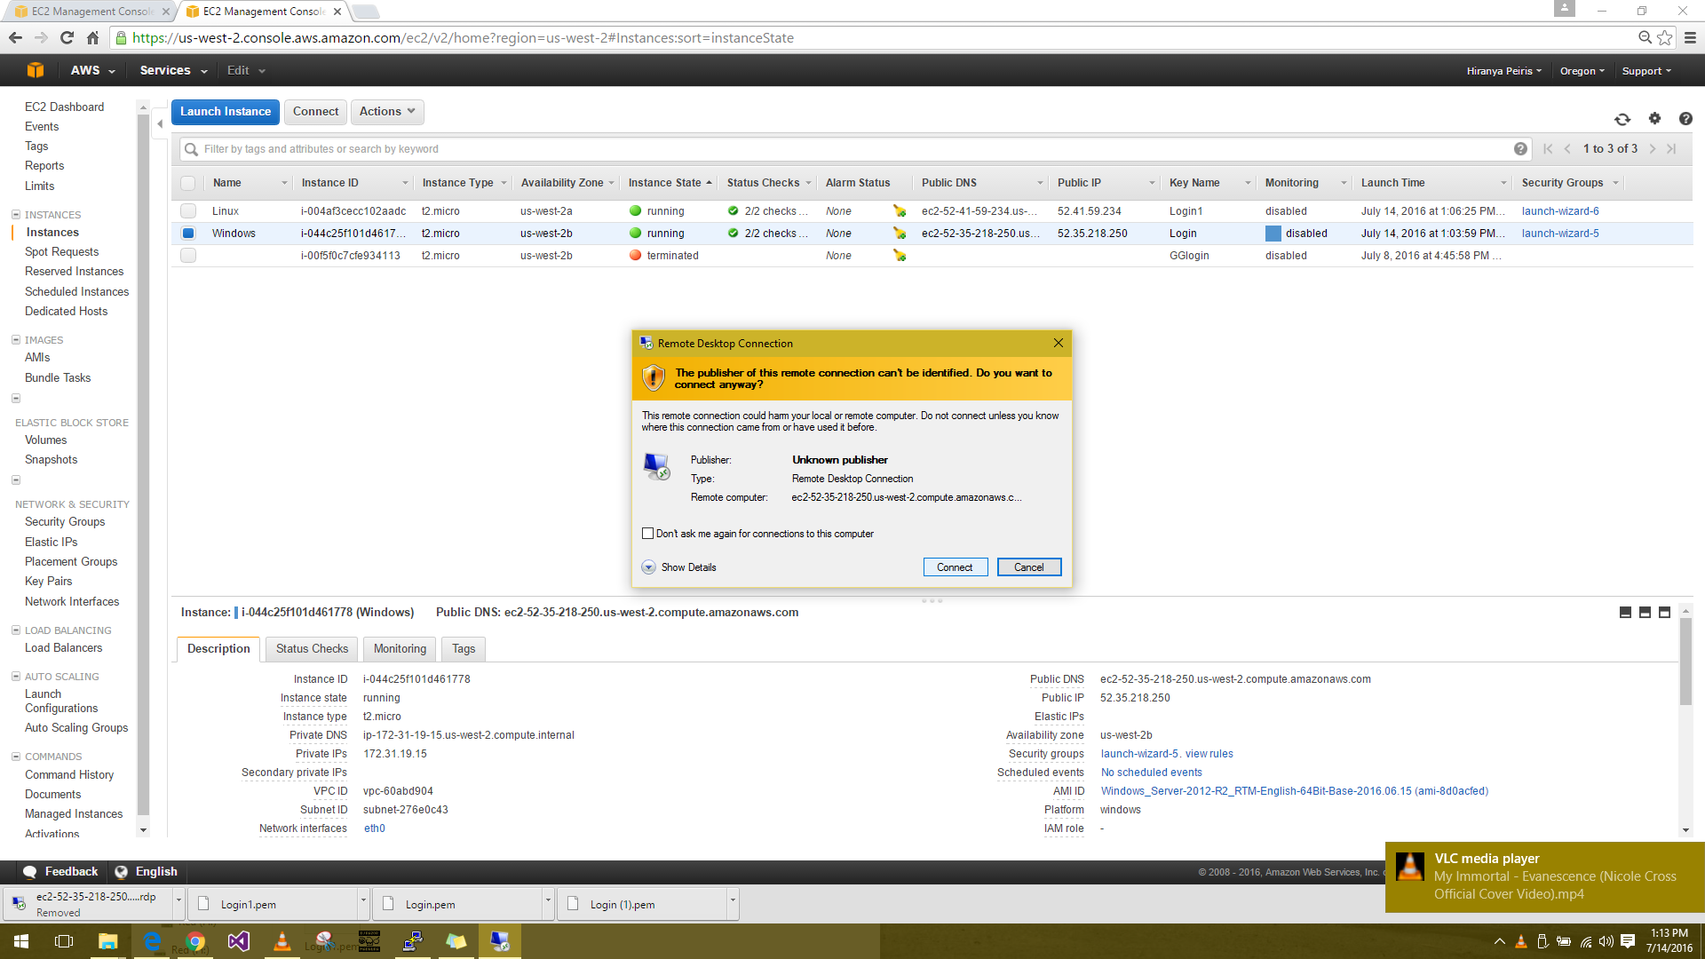

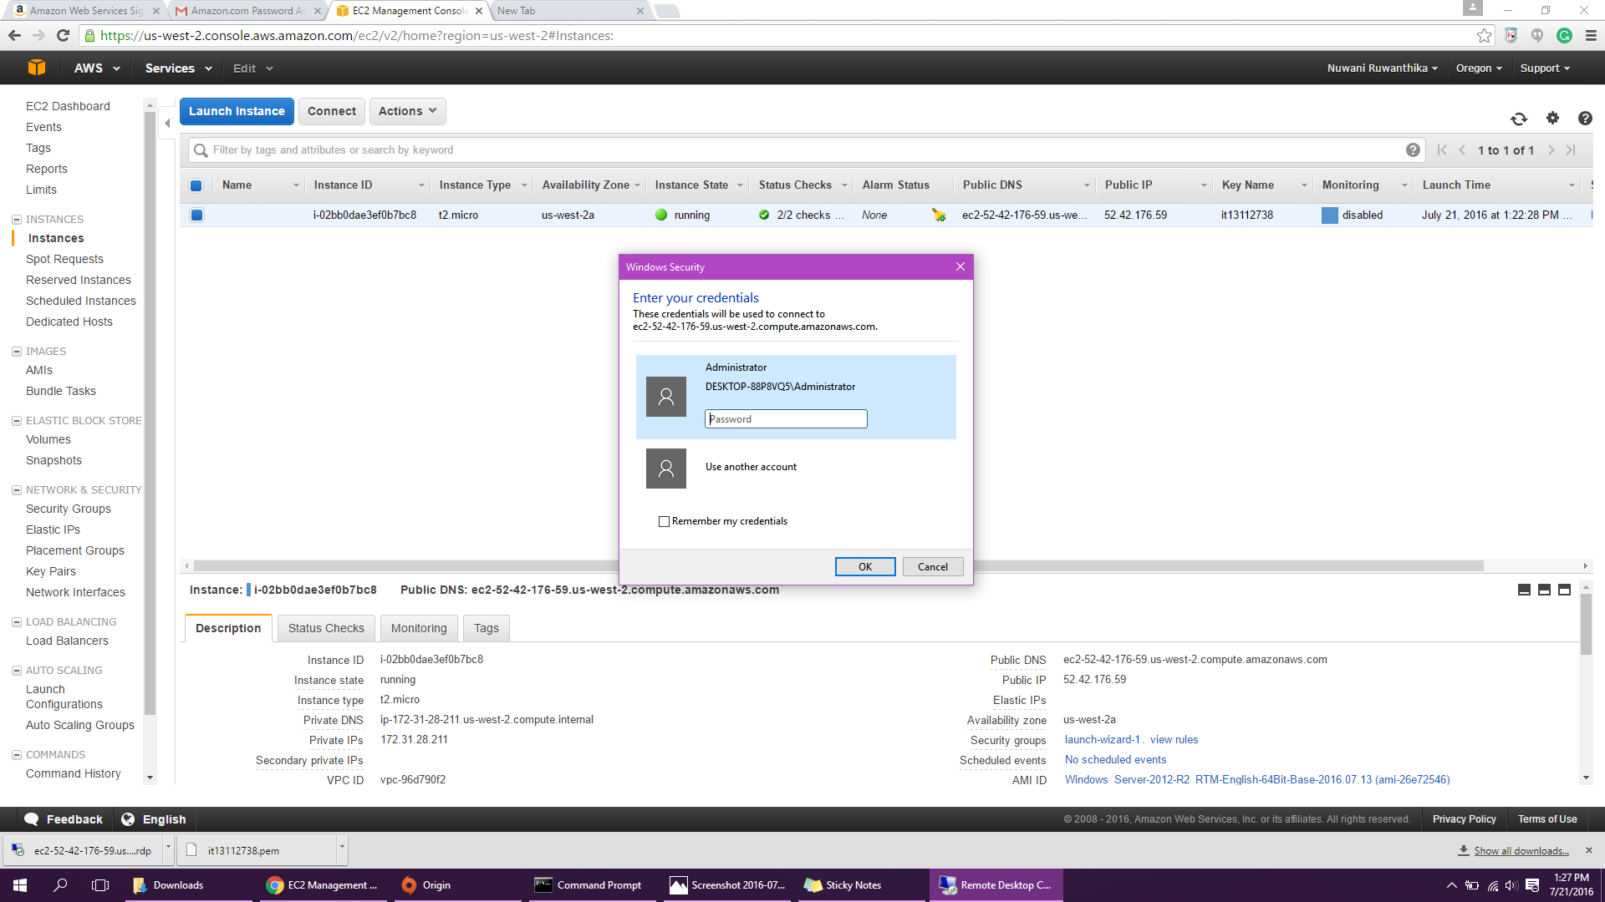

* 1. Choose **Yes** or **Continue** to continue if you trust the certificate.

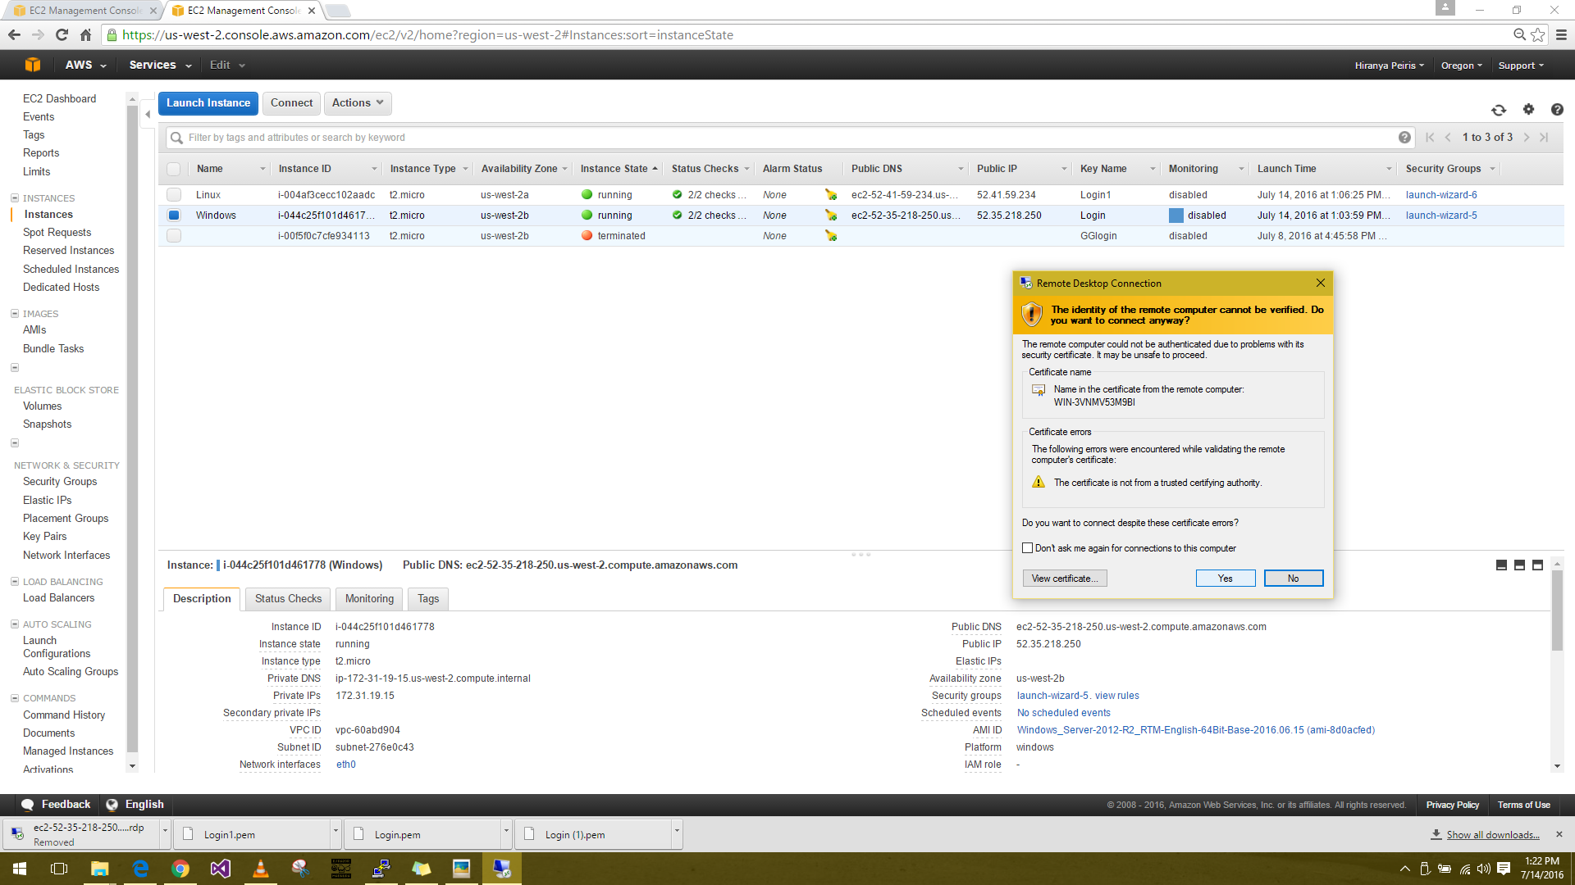

* 1. Using **Remote Desktop Connection** from a Windows PC, choose **View certificate.**

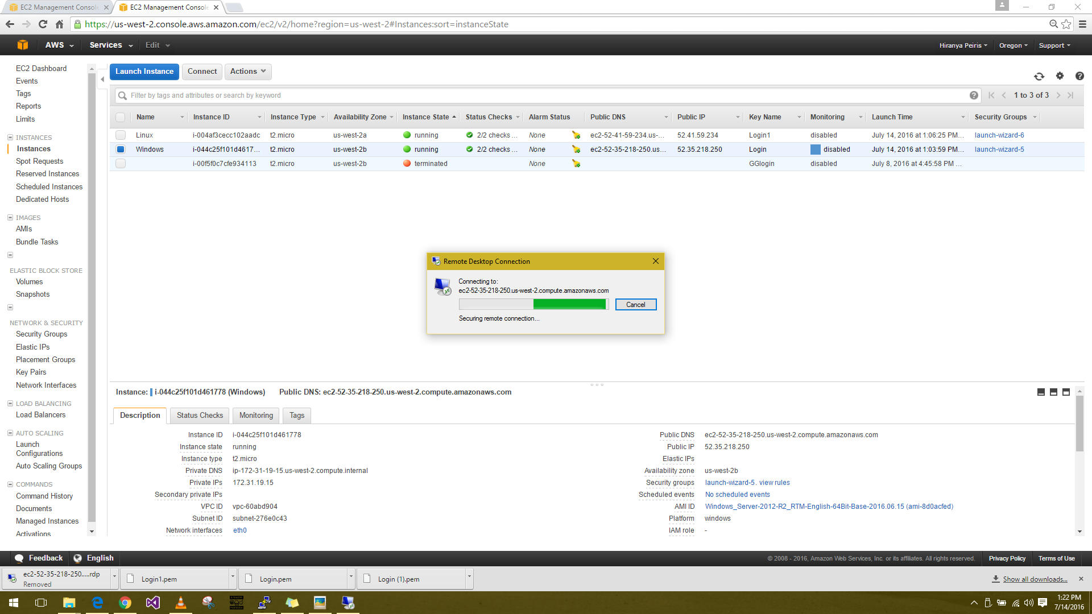

* 1. The launched Amazon EC2 Windows Instance.

